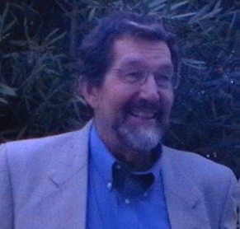

Vale Emeritus Professor Lawrence (Larry) Saha,

The world-wide community of comparative and international education is deeply saddened to announce the passing of Larry Saha, who succumbed to long-term illness on 19 August 2024. Larry held numerous academic positions throughout his distinguished career, most notably at the Australian National University. He was widely respected in the CIE community as a brilliant researcher, dedicated mentor, and esteemed colleague.

Larry was born and raised in Houston Texas, and although he spent over 40 years pursuing his academic career in Australia, his work had a truly global reach. He held academic positions and collaborated in Brazil, Canada, France, New Zealand, Norway, Sweden, and the USA, embodying the spirit of an international scholar. His collaboration with Stockholm University's Ingemar Fägerlind on *Education and National Development: A Comparative Perspective* (1983, 1989) was a ground-breaking contribution to the field of educational development and played a key role in elevating UNESCO's International Institute for Educational Planning (IIEP) on the global stage. Larry has left an enduring legacy through his collaborations, mentorship, and unwavering support of scholars in their academic journeys. He inspired and impacted all who had the privilege of working with him.

The communities of NOCIES and GlobalCIE extend the deepest of condolences to Larry's family, as well to the many colleagues and students in the CIE community who are mourning this profound loss.